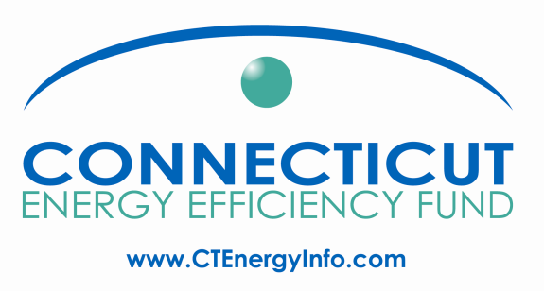

Energy Efficiency Board
Marketing Committee Meeting
Wednesday, March 7, 2012, 2:30 – 4:00 PM
Department of Energy and Environmental Protection
79 Elm Street, Hartford, Connecticut – Ensign Room, 5th Floor
Call-in number – 800-655-1109 Passcode – 875 8697
Meeting Materials available at: http://www.box.com/s/vldrbv639agfj56rjhi5

Agenda

- Review Agenda

- Update on collaboration with DEEP & CEFIA on joint statewide branding / website / outreach & marketing project –
  - Marketing Services contractor selection – Discuss ClearResult workplan, budget and purchase order
  - Review pertinent energy efficiency-related issues

- Review and approval of the companies’ 2012 Program Marketing Plan

- Proposed committee meeting calendar revisions – switch to monthly meetings for next half year:

  - April 4
  - May 2
  - June 6
  - July 3
  - August 1
  - September 5
  - October 3
  - November 7

- Other business

